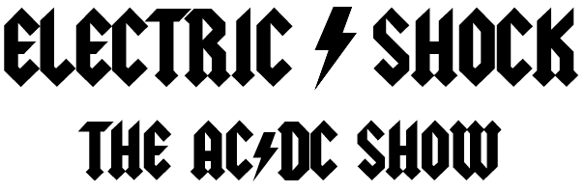

Since 2014, ELECTRIC SHOCK has been perfecting the AC*DC show with a high energy performance, faithfully replicating AC*DC both musically and visually, proving they are the nations #1 AC*DC show! Playing all the classic hits and deeper cuts from both Bon Scott and Brian Johnson eras! This show is not just a tribute, but an experience that will give you the look, feel and sound like you are witnessing an actual AC*DC concert!

ELECTRIC SHOCK’s “Angus Young” Johnny Degiorgio, who is originally from Australia and standing at a height of 5’2” tall, Johnny has meticulously been playing the role of Angus since the early 90’s in Australia under the band Dirty Deeds. For over 20 years Johnny has dedicated his passion to mirroring Angus’s schoolboy uniform, duckwalk, and guitar solos! Note for note he does justice to his hometown heroes using the same gear to achieve their iconic sound, with an original 1961 Gibson SG straight into Marshall Plexi heads, no pedals, just attitude and a wall of Marshall stacks!

His counterpart Eric Richeal, pays homage to Malcolm Young’s looks and authentic tone. He uses identical Gretsch guitars strung up with the same thick string gauges Malcolm uses, which is integral for the driving force of AC*DC’s rhythm. On vocals, DJ Ludowitz delivers an amazing vocal range, who has been quoted as “A young Brian Johnson that can still hit the high notes!” The backbone of the band is provided by bassist Darren Followwill, who thumps steadily throughout the night with the roar of the Ampeg refrigerator cabinet! You can hear the thunderous drums of Tom Ramirez, who plays true to Phil Rudd; no-nonsense, simple perfection, and rock-solid timing! He hammers away on the Phil Rudd signature series Sonor drumkit with an impressive spread of Paiste 2002 cymbals just like Phil!

ELECTRIC SHOCK has rocked the Midwest, appearing in various casinos, festivals, music venues, and special events across Nebraska, Iowa, Illinois and Wisconsin. ELECTRIC SHOCK has performed as the opening act for Heart, Blue Oyster Cult, Firehouse, Head East, Jackyl, Drowning Pool, Lynch Mob, and Hairball!
Now embarking on their 10 year anniversary “Long Way to the Top” 2024 tour, relive the best years of rock & roll with a concert you’ll never forget. Let There Be Rock!
Booking@ElectricsShockBand.com


